Introduction

The fastest way to get an answer from your data is to ask a question using natural language. Q&A picks the best visual based on the data. Sometimes data is defined as a certain type or category, which helps Q&A know how to display it. The Q&A feature in Power BI lets you explore your data in your own words. Q&A is available on dashboards and on reports. This article is written for business users and explains how to use the Q&A feature in a report.

Follow the below steps to use Q&A visuals in Power BI Desktop.

**Step 1.** Launch Power BI.

**Step 2.**Connect with the data.

**Step 3.** In the Home tab click the drop-down near Visuals.

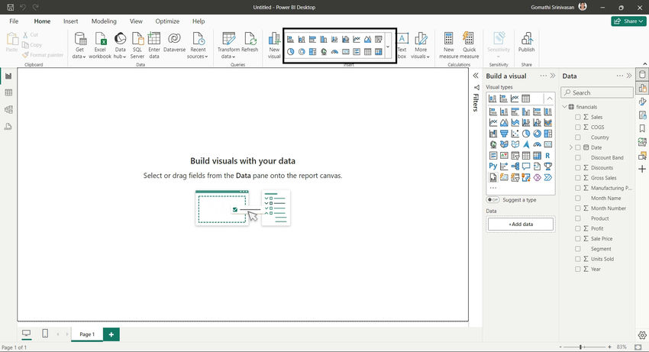

**Step 4.** Select Q&A Visuals.

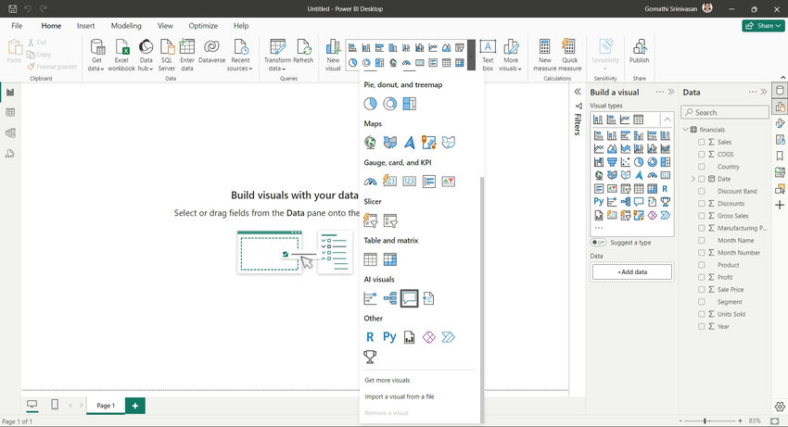

**Step 5.**You can see the Q&A visuals inserted on the page

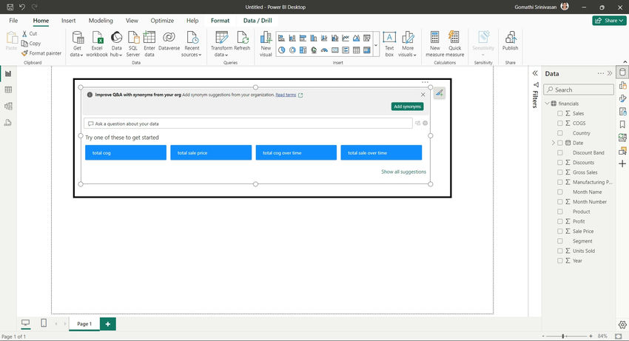

**Step 6.**Type the question to ask anything from Q&A visuals.

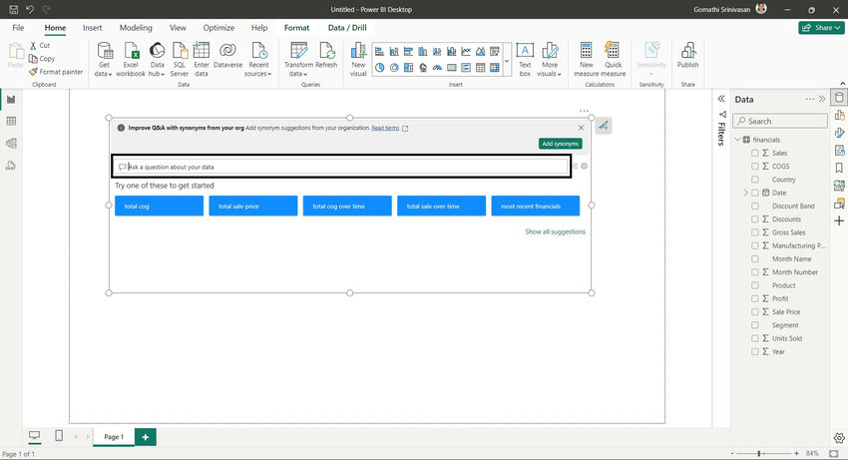

**Step 7.**For example, I have entered the question "What is average sales per product". You can see the below visual.

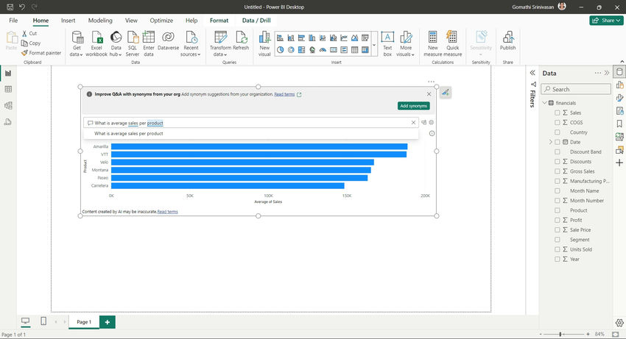

**Step 8.** You can refine further by using the "as" keyword. For example "What is average sales by country as map".

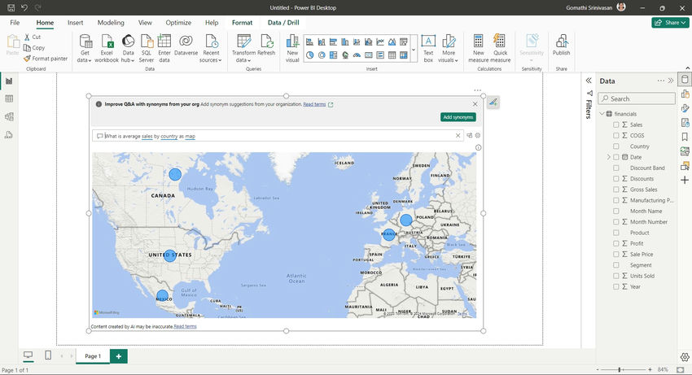

Conclusion

Q&A picks the best visual based on the data. If you want a specific type of visual, tell Q&A which one to use by adding it to your question.  Sometimes data is defined as a certain type or category, which helps Q&A know how to display it. Data that is categorized as a city is more likely to be displayed as a map.